Week1 Day1 Assignment
Home Assignment
User story reviewer Agent
--API Request
--Parser(Stringify)
--Groq(Title,Desciprition and acceptance criteria)
--Prompt Template(prompt variable{})
--Groq(Generate the review score)
--Save file (txt)

LangFlow
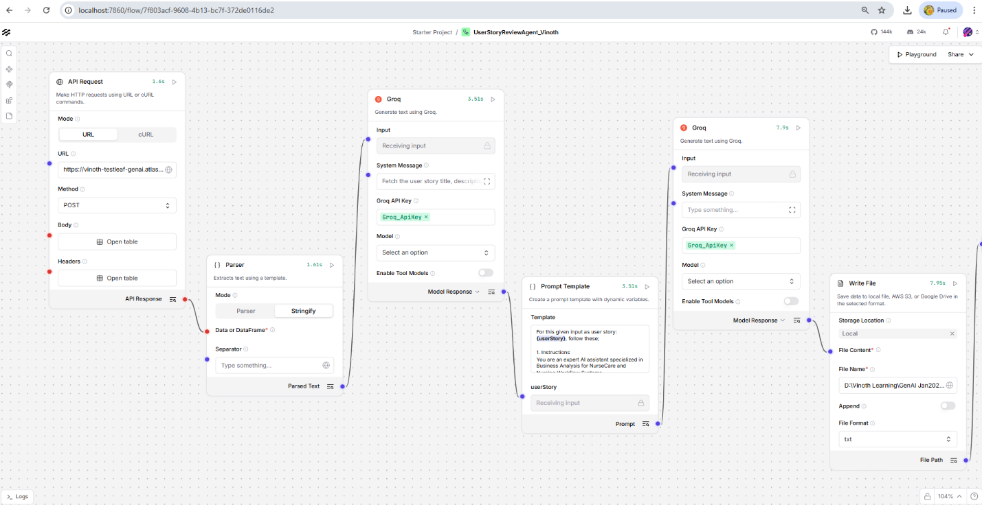

Html output
